**International School, Duy Tan University**



CAPSTONE PROJECT 1

Grace Coffee Management

**INTERFACE DESIGN DOCUMENT**

Version 1.0

05/10/2018

**Mentor: MSc. Nguyen Minh Nhat**

**Group Name: Hasagi Team**

**Project Information**

|  |  |
| --- | --- |
| Project Title | Grace Coffee Management (GCM) |
| Start Date – End Date | 20/09/2018 to 1/12/2018 |
| Lead Institution | International School, Duy Tan University |
| Project Mentor | Msc Nguyen Minh Nhat |
| Project Manager & Contact detail | Project Leader, Pham Tan Anh Khoa  K21CMUTPM2, International School, Duy Tan University  Mail: [phamanhkhoa0@gmail.com](mailto:phamanhkhoa0@gmail.com)  Tel: +84 1886240924 |
| Team member | Nguyen Quoc Bao – Email: [nguyenquocbao19182@gmail.com](mailto:nguyenquocbao19182@gmail.com)  Vo Ngoc Tin - Email: [tin.vongoc.54@gmail.com](mailto:tin.vongoc.54@gmail.com)  Tran Anh Tai - Email: [iitaitran57696@gmail.com](mailto:iitaitran57696@gmail.com) |

**Document Information**

|  |  |
| --- | --- |
| Project | Grace Coffee Management |
| Document Title | Interface Design Document |
| Creator | Nguyen Quoc Bao |

**Revision History**

|  |  |  |  |
| --- | --- | --- | --- |
| Version | Person | Date | Description |
| 1.0 | Nguyen Quoc Bao | 01-Sep - 2018 | Offical |

**Document Approval**

The following signatures are required for approval of this document

**Prepared by**

Pham Tan Anh Khoa Date

*Team Leader*

1. **Introduction**
   1. **Purpose**

* This document describes the design “Interface of Applying AI in Grace Coffee Management”.
  1. **Scope**
* Overview of the stages and modules of the software.
* Create complete interfaces and describe them clearly.

1. **List of User Interface Designs**

|  |  |  |
| --- | --- | --- |
| User Interface ID | UI Name | Description |
| UI – 01 | Login | This will display form Login |
| UI – 02 | Home Page | This will display information of the plants as the humidity, the current temperature. Displays the date, time, mode, etc. |
| UI – 03 | Custom System Page | This will displaying custom items of system equipment such as turning on the pump, turning on lights, etc. |
| UI – 04 | Admin Page | This will display form about user management and plant management. Allows admin to edit it. |

1. **UI – 01: Login Page (Web)**

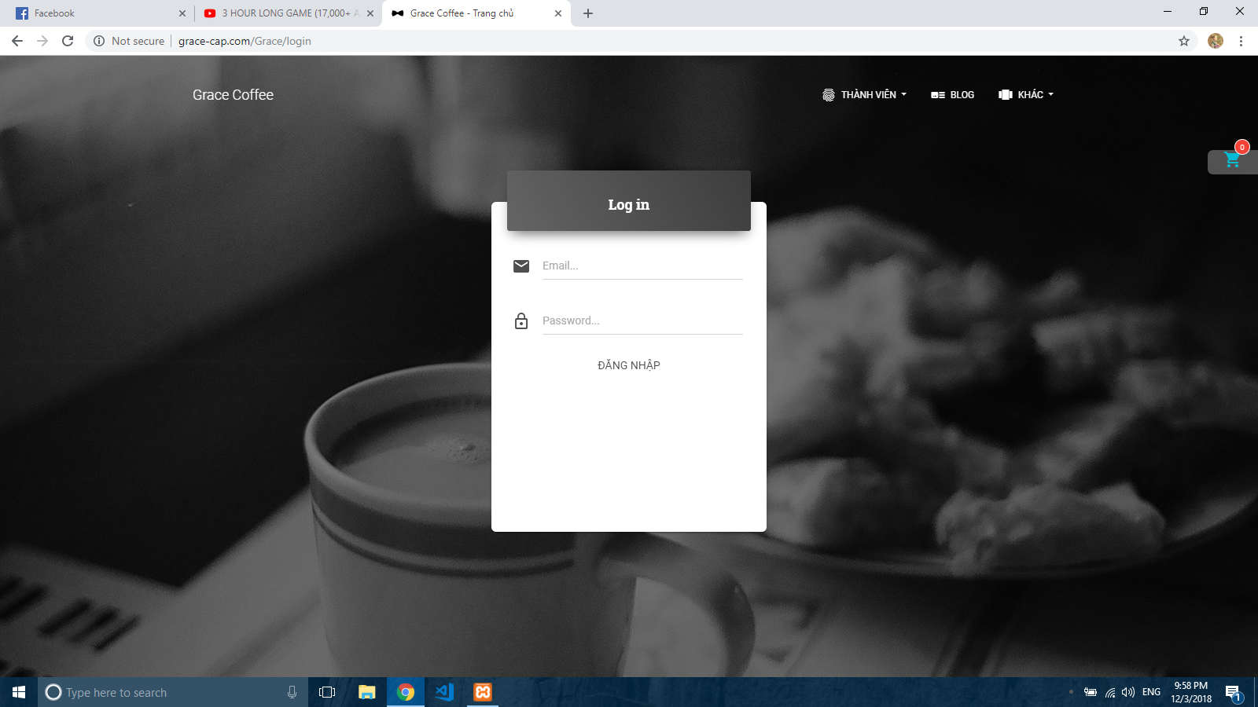

**Picture 1. Login Page (Web)**

1. **UI – 02: Home Page (Web)**

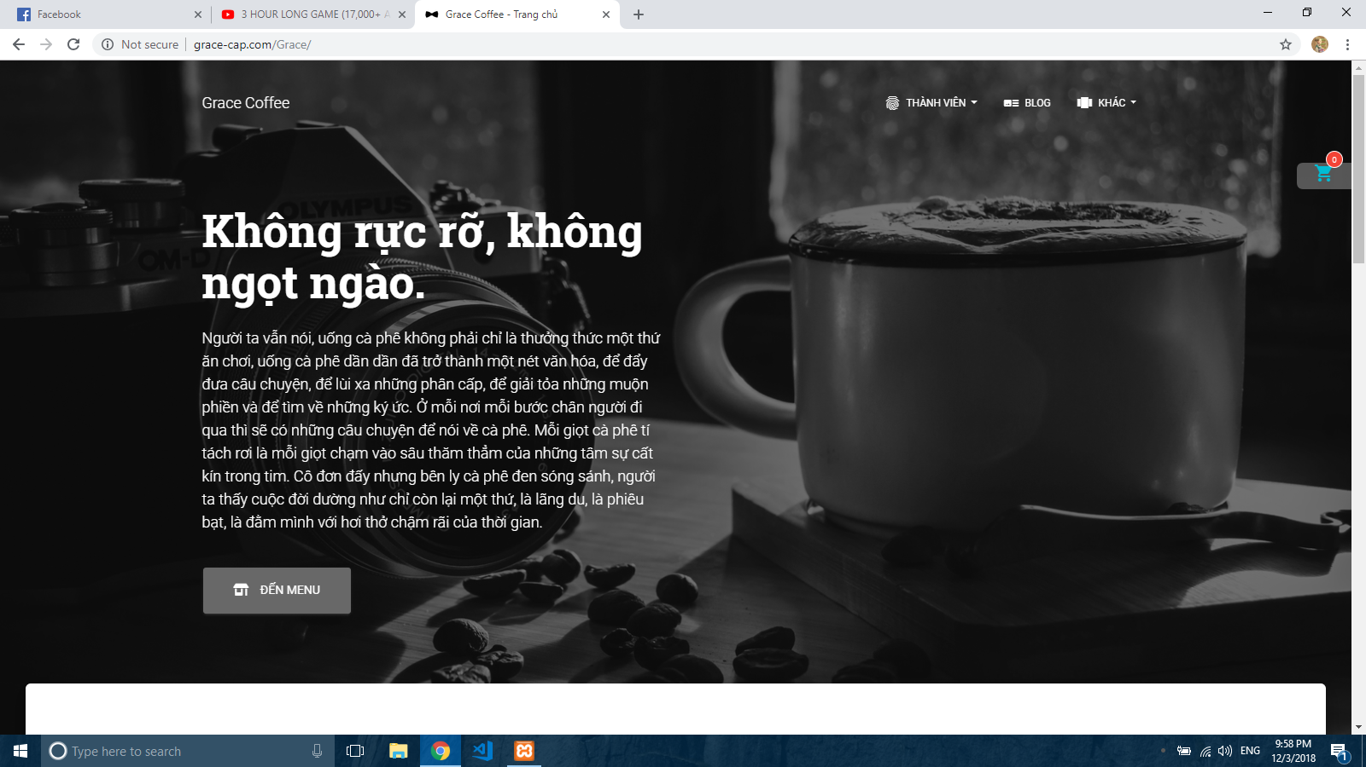

**Picture 2. Home Page (Web)**

**UI – 03: Shopping cart(Web)**

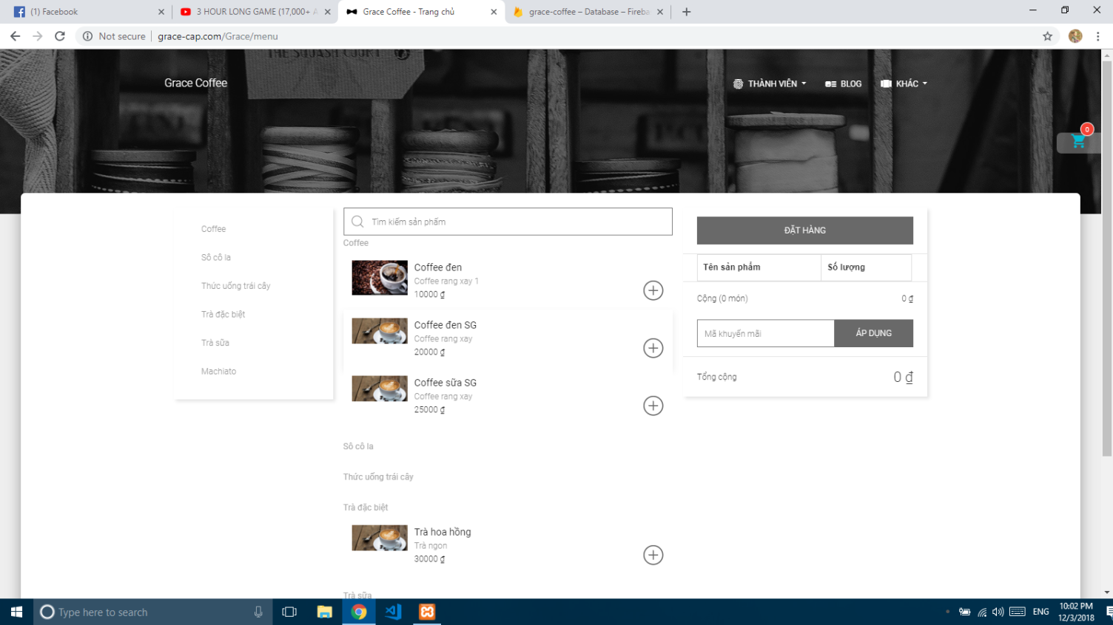

**Picture 3. Custom System Page (Web)**

**UI – 04: Add product into shopping cart(Web)**

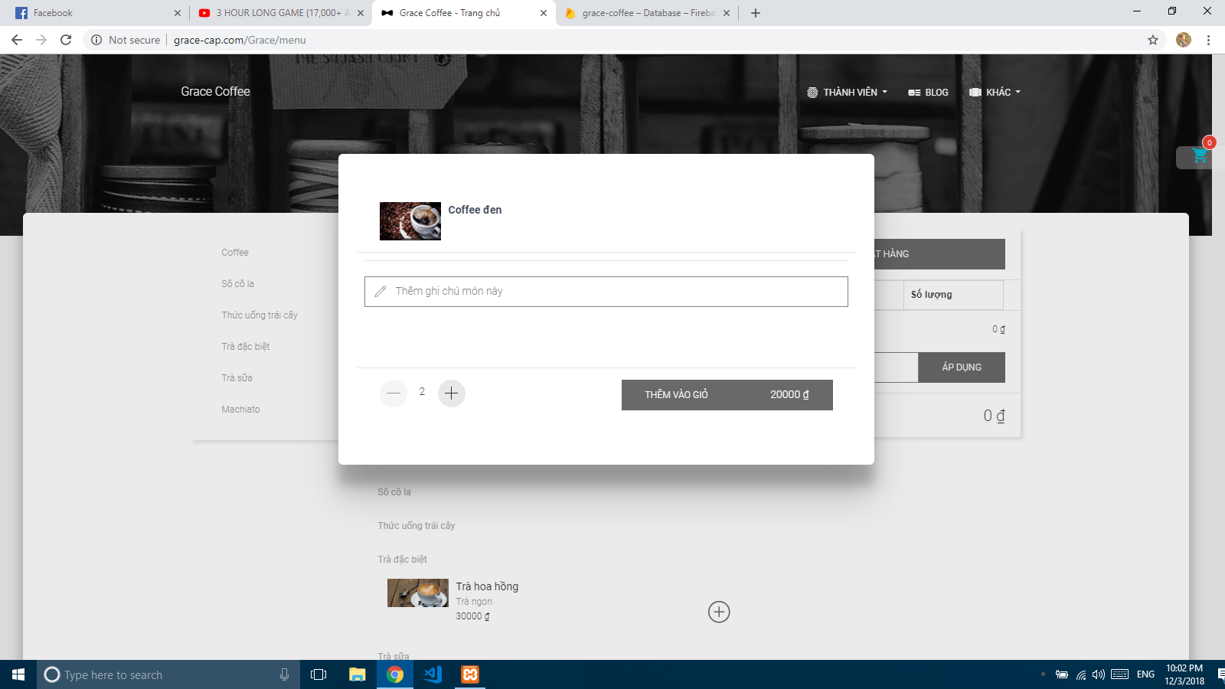

**Picture 4.1 Manage User Page (Demo Interface)**

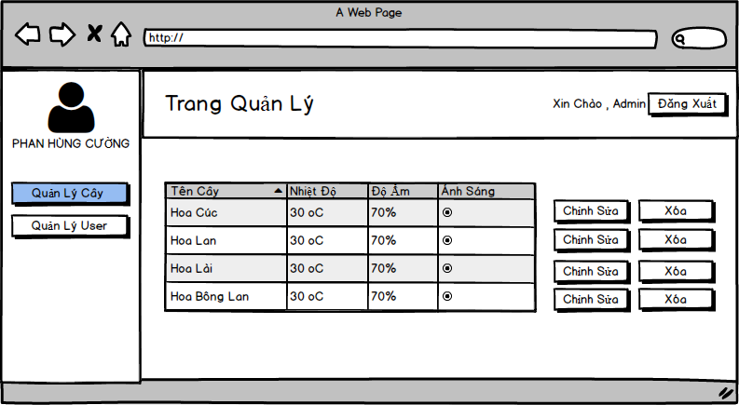

**Picture 4.2 Manage Plant Page (Demo Interface)**